TIP PLATFORM
TECHNOLOGY, IMPLEMENTATION, POLICY PLATFORM

In order to lead implementation based on developed policies and technologies, TIP Platform (Total 10 sessions) will serve as an arena/ means/ media to
- Share appropriate and innovative technologies and policies to implement solutions to challenges
- Share best practices and cases for further application of solutions
- Bridge developed and developing countries by exchanging their technologies and policies
Social
Government,
Local Authorities, Int’l Organizations
Economic
Environmental
Scientist, Engineers, Expert Community, Industry Community
Government, Local Authorities, Industry Community, Citizens, etc.

TIP Platform focuses on a number of areas where science and technology provides a major opportunity to innovate water resources management and environmental security, simultaneously, where the development of relevant policy offers socio-economic opportunities and supports the process of technological application and its development. A number of areas have been carefully selected and are described below.

BACKGROUND
Current and future water solutions are highly dependent on the use of scientific research, new technologies and innovation processes. The challenges for water resources management are complex, which include rapid urbanization, population growth, climate change, industrialization, a surge of energy demand, disaster impacts, water-energy-food nexus, and massive pollution of water, soil and air. Many of them form the basis for the discussions of the global community around the Sustainable Development Goals (SDGs). In the whole process, the policy-making process and development considering science and technologies became more important and the linkage between two pillars, technology and policy, will be the key to making implementation possible for all actors. Science and technology and its ties with policy making do not appear to tackle all the mounting challenges in the water sector. These circumstances signify the urgency for a ground-breaking and brand-new commitment from the perspectives of technology and policy simultaneously so as to make good practices.
To properly address the above challenges, we need to focus on and invest in the processes of innovation in the water (and related) sectors as follows: Firstly, it is to create a better understanding on how innovation and application of technologies in the water sectors works and how it can contribute to profound changes at scale. Secondly, it requires renewing political will from key decision makers in both the public and private sectors to invest in water innovations, from fundamental research, to piloting new technologies, to wide scale applications. Finally, it also requires the mobilization of an entrepreneurial spirit which not only provides practical solutions for problem owners but also helps make technologies useful for industries.
OBJECTIVE
The objective of TIP platform is to promote global discussion on practical solutions for water challenges at various scales. The platform will be designed to provide practical and innovative guidelines to those who seek for practical know-hows and lessons learned from successful implementation of water policies. It also aims to provide market places with emerging science and technologies and engineering services for active engagement in global water issues. The activities of TIP platform in KIWW will develop a robust network for international cooperation in water sectors and provide practical advice for further projects and future collaborative works.

THREE KEY WORDS
TIP Platform seeks to be based upon three core keywords, technology, implementation, and policy.
- Technology in Feasibility study, Design, Construction, Operation, Maintenance, Monitoring, Treatment, Restoration, ICT including Artificial Intelligence (AI), Big Data, etc.
- Policy linked with technologies and implementation promoting efficiency, sustainability, partnership, governance, green economy, culture, and environment
- Implementation by sharing best practices, strategies, and processes based on well-defined policies and both appropriate and developed technologies

FOCUS AREAS
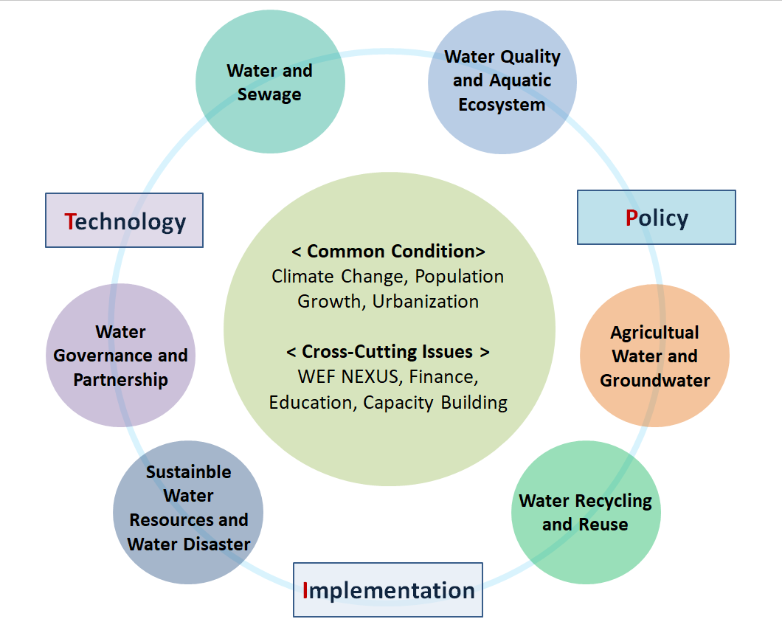Technology, Policy, Implementation as TIP cross-cutting words

Focus Areas below are aimed to define practical solutions for achieving Sustainable Development Goals on water and consequently provide action tools and tangible strategies.
- Focus 1: Sustainable Water Resources and Water Disaster
Keywords: Securing Water Resources, Water Allocation, Climate Crisis, Floods and Droughts, Water Security, Resilience, Disaster Risk Reduction, Sustainable Infrastructure, Integrated Water Resources Management, Climate Change Adaptation
Sustainable Water Resources and Water Disaster aim to ensure the sustainable management of water resources while addressing water-related disasters. It explores strategies for efficient water allocation, conservation, and protection of water sources. Additionally, it emphasizes the importance of flood and drought management, water security, resilience, and disaster risk reduction. Discussions in this area revolve around integrated water resources management, sustainable water infrastructure development, climate change adaptation, and the preservation of ecosystems and biodiversity.

- Focus 2: Water and Sewage (Industrial Water)
Keywords: Water and Sewage Management, Water Treatment, Water Efficiency, Sustainable Urban Water Systems, Circular Economy, Water Security, Resource Efficiency, Water Supply System, Water related Big Data
Water and sewage centers around the efficient management and treatment of water in urban and industrial contexts. It involves ensuring reliable water supply, improving sanitation and wastewater treatment, promoting water efficiency, and fostering sustainable water use. Meeting these challenges requires the adoption of advanced technologies for water treatment and reuse, the development of sustainable urban water systems that minimize water waste and maximize resource efficiency, the implementation of circular economy principles to reduce the environmental impact of industrial processes, and the establishment of effective water governance frameworks.

- Focus 3: Water Quality Management and Aquatic Ecosystem
Keywords: Sustainability, Climate Change, Green Infrastructure, Carbon Emission, Energy Recovery, Resilience, Economic and Environmental benefits, Decentralized Systems, Eutrophication, Diffuse pollution
Water quality management focuses on maintaining and improving the quality of water resources, with a special emphasis on preserving the health and integrity of aquatic ecosystems. It encompasses the monitoring and assessment of water quality parameters, the prevention and control of water pollution, the development of effective treatment technologies, and the conservation of aquatic biodiversity. The challenges within this focus area include ensuring compliance with water quality standards, reducing pollution from various sources, mitigating the impact of contaminants on aquatic organisms and ecosystems, and promoting sustainable water use practices. To address these challenges, robust monitoring systems need to be established to ensure water quality standards are met, pollution prevention measures should be implemented, innovative treatment technologies should be deployed, and comprehensive regulatory frameworks must be put in place to protect ecosystems and safeguard public health.

- Focus 4: Agricultural Water and Groundwater
Keywords: Irrigation Practices, Water-saving technologies, Precision Irrigation, Smart Farming, Groundwater Protection, Water-efficient Policies, Water-Food Security Nexus
Agricultural water and groundwater focus on the challenges related to water use in agriculture and the sustainable management of groundwater resources. It involves promoting efficient irrigation practices, adopting water-saving technologies, implementing integrated water resource management approaches in agricultural systems, and ensuring the sustainable use of groundwater. Addressing these challenges necessitates the adoption of water-efficient irrigation technologies, the promotion of sustainable agricultural practices, the protection of groundwater quality and quantity through appropriate monitoring and management, and the formulation and implementation of water-efficient agricultural policies.
- Focus 5: Water Recycling and Reuse
Keywords: Sustainability, Climate Change, Green Infrastructure, Carbon Emission, Energy Recovery, Resilience, Wastewater Treatment, Water Reuse, Economic and Environmental benefits, Decentralized Systems, Public Health
Water recycling can contribute to enhancing the sustainability of the global water and environment, which suffers from climate change, excessive carbon emission and energy consumption, water deficit, and floods. It is a series of processes of reusing treated wastewater for industrial processes, agricultural and landscape irrigation, toilet flushing, and ground water recharge. The challenges associated with water recycling and reuse can be wastewater technologies, legal and regulatory preparation, and social agreement. Efficient and appropriate technologies are required for diverse purposes of water use. It is also inevitable to set up relevant laws and regulations and forms a social consensus concerning the recycling and reuse process in the implementation.

- Focus 6: Water Governance and Partnership

Keywords: Trans-boundary Water Issues, Public Policies, Sound Water Governance, Gap Bridging with Science and Technologies
Water governance is important in developing and managing water resources, and contributes to tangible public policies and implementation through a shared responsibility across all stakeholders, based on effectiveness, efficiency, participation and trust. The stakeholders include policy-makers, government agencies, water industry, civil society and NGOs, who play an important role in enhancing the water resources management towards equity, economic efficiency, and environmental sustainability. Integrated water resources management is one of the conceptual methodologies that reflect the effective governance. Partnership, one of the important factors for good governance, is one of the most effective ways to manage or develop the water resources, which have a characteristic of spatial and temporal availability and movement. Partnership can have various types of the organization scheme such as public-public or public-private partnerships, etc. depending on the characteristics of project objectives. Since the collaboration of partners also creates a synergy in achieving the goals of water management, the partnership among related stakeholders needs to be issue for efficient water management.

